Topic: Measurement | EQ: What are the different units of measurement
Questions  Length  Capacity  Mass/weight | Notes:  Millimetres (mm), centre metres (cm), metres (m), kilometre (km)  Used for measuring; length, width, and distances  Millilitres (mL), litres (L) and kilolitres (kL)  Used for measuring liquid units  milligrams (mg), grams (g) and kilograms (kg)

WORKSHEET
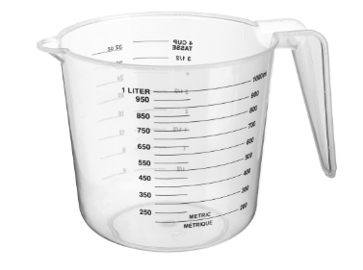  Looking at the Jug  - What do we use a jug like this to measure?  Length, capacity, mass  - Which unit do we use with this jug? | 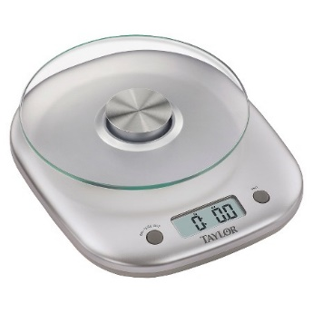  Look at the scales  - What do we measure with scales like this?  Length, capacity, mass  - Which units can we use with this scale?
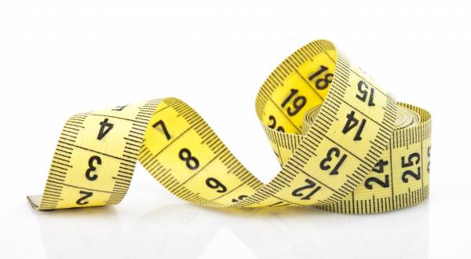  Look at the measuring tape  - What do we measure with this?  Length, capacity, mass  - Which units do we use? | 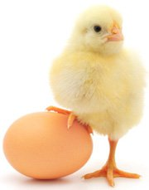  Which unit is best for measuring the mass of the egg?
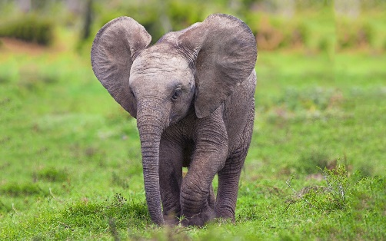  Which unit is best to measure the mass of this baby elephant? |   (Photo: Mr Morgan’s son Beau)  Which unit is best to measure the mass of this baby human?
Which units would be best to measure….
- The length of a kitten head to tail?

- The length of a finger nail?

- The mass of a car?

- The distance from Perth to Sydney?

- How far someone jumps in long jump?

- The mass of a small rock?

- The mass of a cup of flour?

- The amount of water in a glass?

- The amount of milk in a carton?

